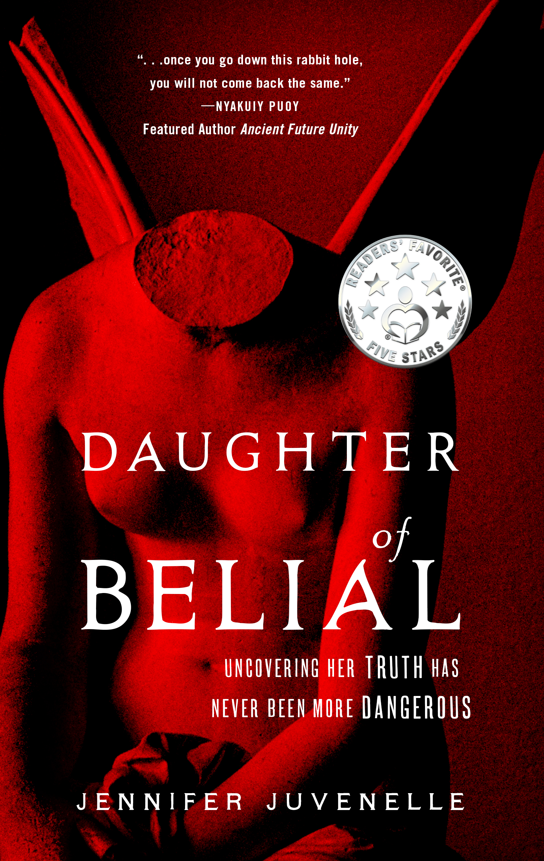
FOR IMMEDIATE RELEASE
CONTACT: Jennifer Juvenelle
e: jennifer.juvenelle@gmail.com
p: +1 310-880-4285

Survivor of Childhood Sexual Abuse Releases Dark Psychological Thriller About a Young Woman’s Fight for Survival Inside the Underground Sex Trafficking Ring of an Elite Secret Society

FORT MYERS, FL — OCTOBER 10, 2022 — The first book in a dark psychological thriller series from survivor of childhood sexual abuse, Jennifer Juvenelle, explores the connection between the global elite’s secret societies and ritual sexual abuse in this gripping debut novel that blends conspiracy theory with underground child human trafficking networks à la Jeffrey Epstein.

Some family trees should be burned… Greer Girls are special. Greer Girls are rare. Greer Girls are central to the secret Order of Belial.

Sophie Greer knows none of this. All she knows is that her now ex-boyfriend cheated on her, she’s alone working in Paris, and her mysterious billionaire boss is way too interested in her life.

But when Sophie is kidnapped in Moscow while on a business trip, she’s plunged into the dark underbelly of the global elite and a sinister secret society with deep ties to her family; ties that lead to revelations darker than anything Sophie could have imagined.

Betrayed by the man who raised her, and targeted by the illustrious Hughes family, only one thing is certain—family history can be deadly. If Sophie is to survive, she must decide who to trust and what to believe, or risk being crushed beneath the weight of the all-powerful secret Order of Belial.
In Daughter of Belial, ($16.99, By the Pure Sea Books, October 2022) Juvenelle taps her personal history as a survivor of a dark occult ritual to write a thriller that deftly portrays the arc of protagonist, Sophie Greer, who evolves from a grounded, relatable woman to a wiser figure shaped by trauma and fighting for survival. This start to the series introduces the secret Order of Belial as an all-powerful club for sadistic billionaires and Sophie Greer is the one woman with the potential to topple them all—if she can discover her true power and learn how to wield it.

“I began writing Daughter of Belial the same year that I decided to focus on healing the abuse,” says Juvenelle. “Writing the novel was a deeply healing and intuitive process that helped me triumph over trauma. I had to excavate those dark, hidden places within myself to bring forth the truth of the story.”

Juvenelle is a Native American/French author born in Hollywood, raised in Detroit, and fashioned in France. She holds a bachelor of arts from Wayne State University and was formerly an actress and model before turning to writing. Juvenelle now splits her time between crafting page-turning thrillers and the magic of motherhood. An eager explorer, she currently lives in a remote Mexican seaside-jungle village with her debonair Aussie author husband and their young son.
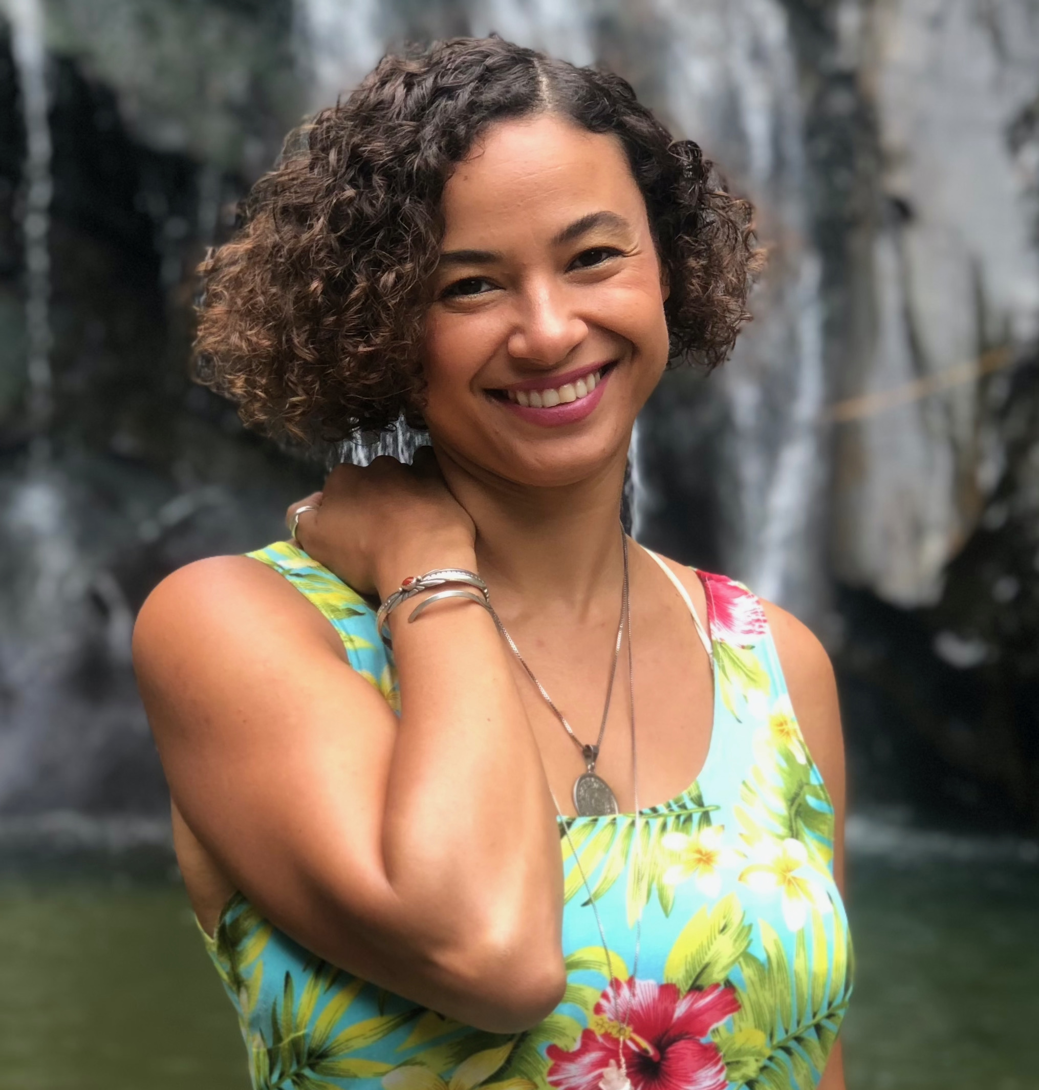
Daughter of Belial ($9.99 Kindle ebook ISBN: 979-8-9867231-0-5, $16.99 paperback, ISBN: 979-8-9867231-1-2, $27.99 ISBN: 979-8-9867231-2-9 hardcover), a 542 page trade paperback and hardcover is available on Amazon and most major online book retailers, and in bookstores. The ebook is available for presale on Amazon. To order, go to https://tinyurl.com/594pmh9d, or for more information about Juvenelle or the Daughter of Belial series, visit www.jenniferjuvenelle.com.

# # #

READER COPIES AVAILABLE UPON REQUEST

“It’s magnificent, all of it…a Machiavellian masterpiece.”
—5 Stars, Jamie Michele, Readers’ Favorite

CONTACT: Jennifer Juvenelle
e: jennifer.juvenelle@gmail.com
p: +1 310-880-4285

