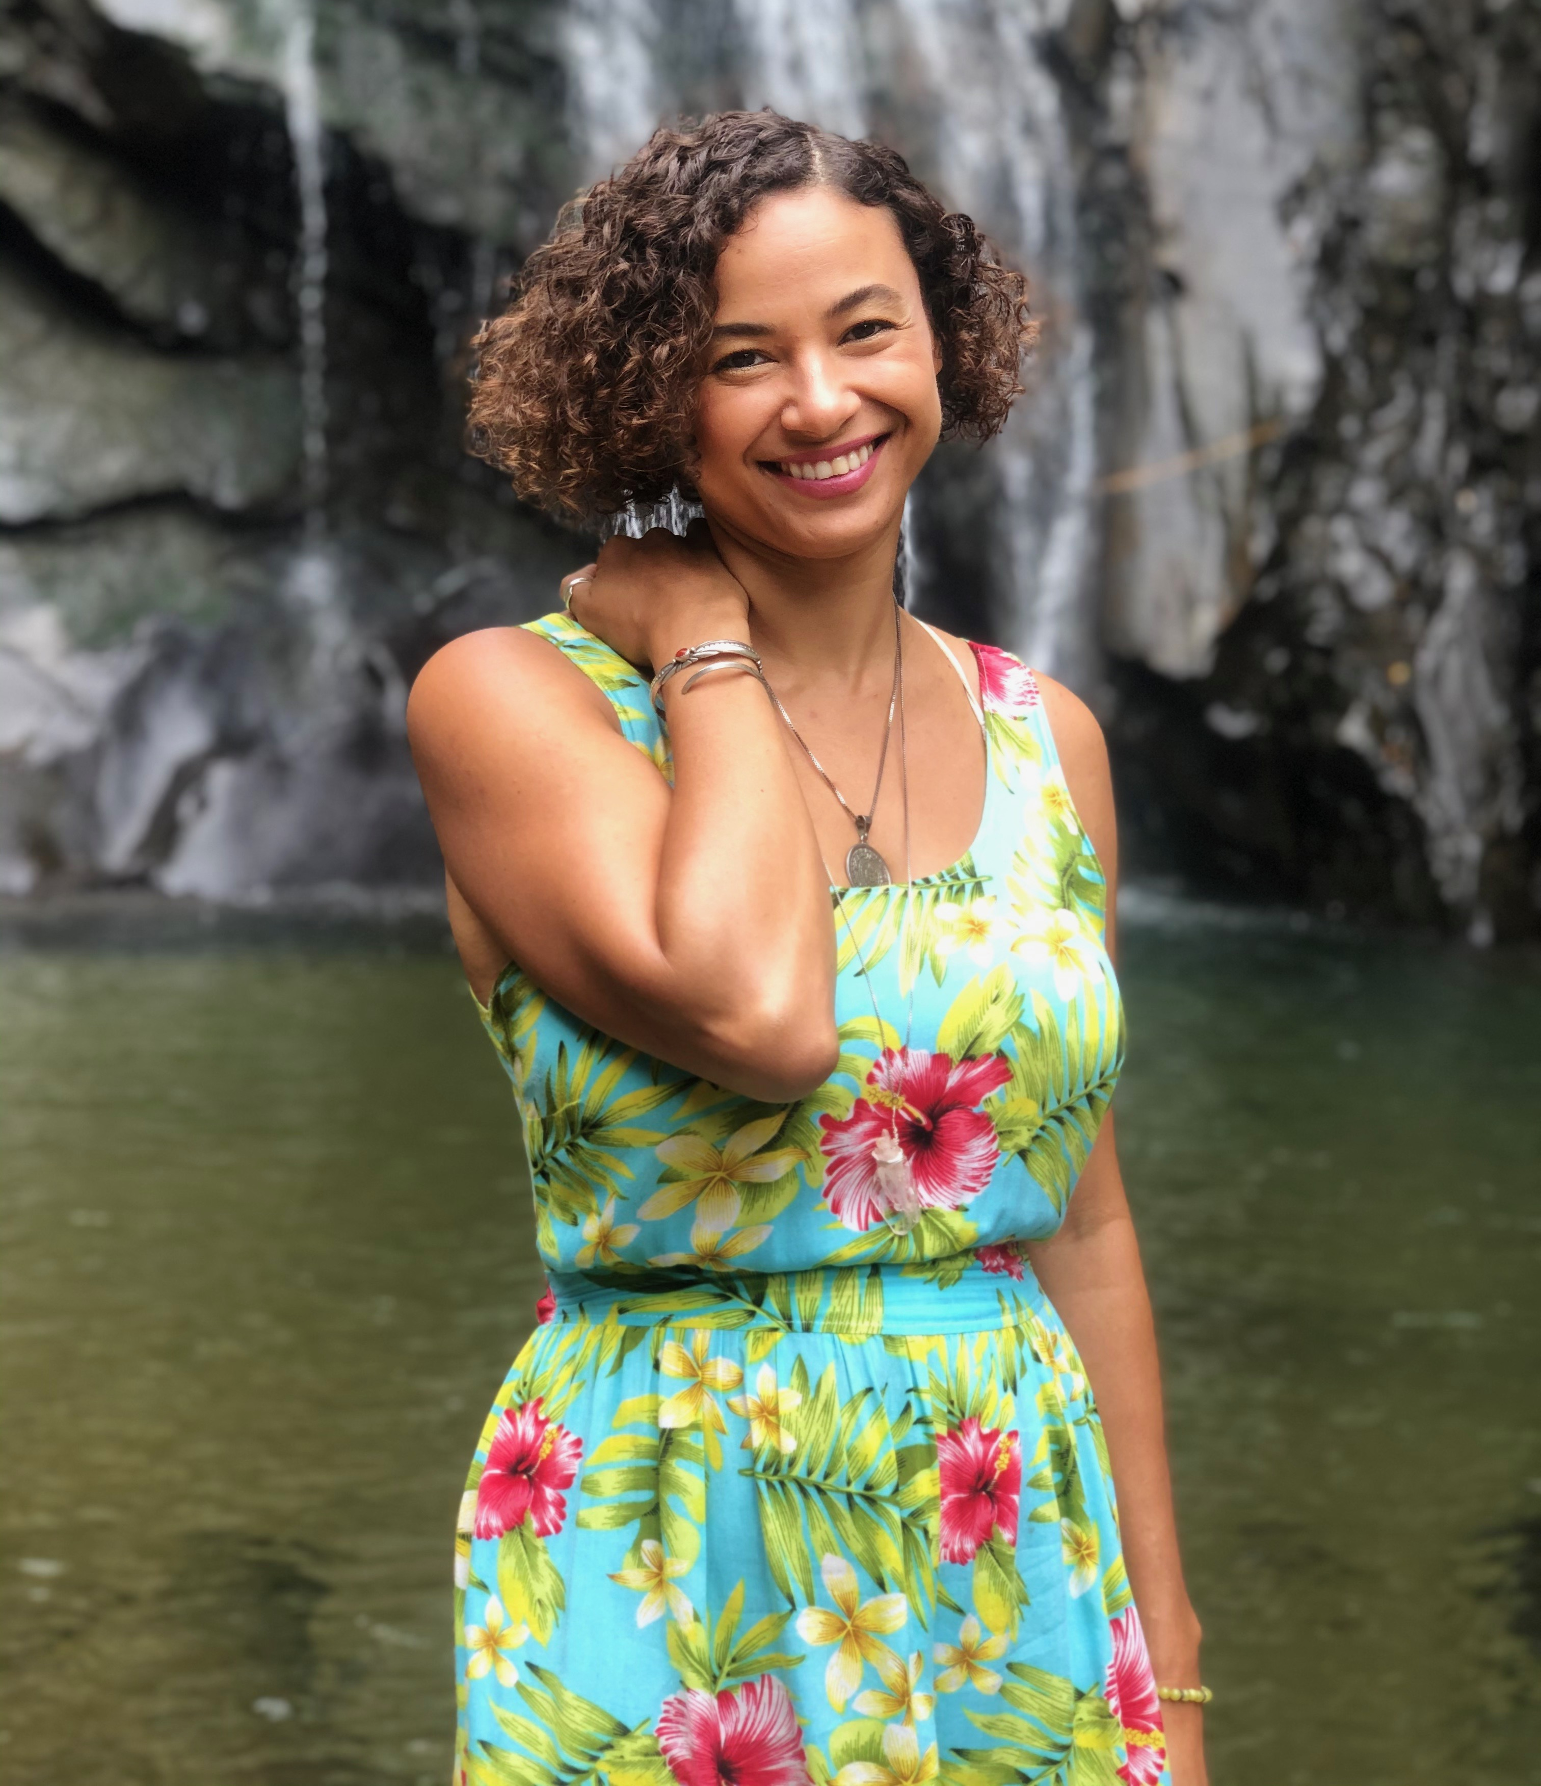
AUTHOR BIO:

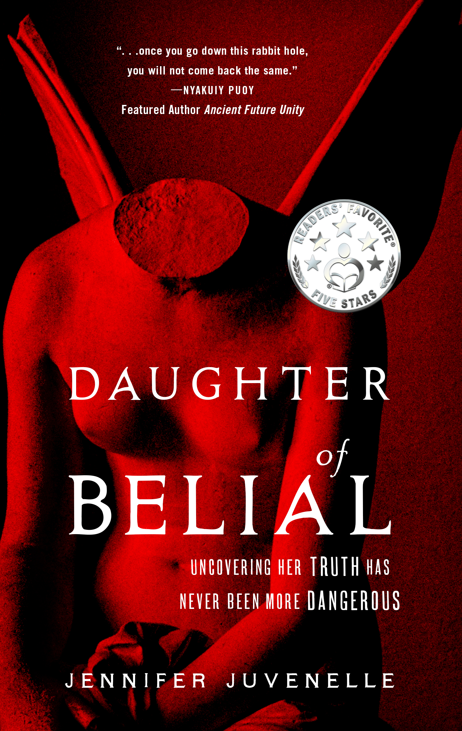
JENNIFER JUVENELLE is a Native American/French author born in Hollywood, raised in Detroit, and fashioned in France. Formerly an actress and model, Jennifer now splits her time between crafting psychological thrillers and the magic of motherhood. A survivor of childhood sexual abuse, Jennifer made healing from trauma a priority when her life became untenable. Daughter of Belial is the unexpected product of her journey from trauma to triumph. Jennifer holds a bachelor of arts degree from Wayne State University. An eager explorer, she currently lives in a remote Mexican seaside-jungle village with her debonair Aussie author husband and their young son.

Daughter of Belial
By Jennifer Juvenelle

Publishing Date: October 10, 2022
Publisher: By the Pure Sea Books
Trade Paperback Edition
ISBN: 979-8-9867231-1-2 (paperback)
RRP: $16.99
Binding: 5.5x8.5 perfect paperback
Page count: 542 pages

Some Family Trees Should Be Burned. . .

Greer Girls are special. Greer Girls are rare. Greer Girls are central to the secret Order of Belial.

Sophie Greer knows none of this. All she knows is that her now ex-boyfriend cheated on her, she’s alone working in Paris, and her mysterious billionaire boss, Edward Hughes, is way too interested in her life. But when Sophie is kidnapped in Moscow while on a business trip, she’s plunged into the dark underbelly of the global elite and a sinister secret society with deep ties to her family; ties that lead to revelations darker than anything Sophie could have imagined.

Betrayed by the man who raised her, and targeted by the illustrious Hughes family, only one thing is certain—family history can be deadly. If Sophie is to survive, she must decide who to trust and what to believe, or risk being crushed beneath the weight of the all-powerful secret Order of Belial.

REVIEWS;

- “Daughter of Belial is beautifully written, completely captivating and... magnificent, all of it. A Machiavellian masterpiece. 5 stars!” – Jamie Michele (Readers’ Favorite)
- “A sharply written, increasingly disturbing tale.” – Kirkus Reviews
- “Phenomenal! One of the best, most electrifying books I’ve read in years.” – Mark T. Rasmussen (author of The Journey)
- “A deep psychological inspection of one woman's move from victim to empowered.” – Midwest Book Review
- “…a rollercoaster of dread and terror. With a start to the Daughter of Belial saga as strong as this, I can’t wait to read the next installment. 5 stars!” – K.C Finn (Readers’ Favorite)
- “...Once you go down this rabbit hole, you will not come back the same. Daughter of Belial is a truly captivating, provocative read.” – Nyakuiy Puoy (Featured author of Ancient Future Unity)

Cover images and other Author photos below

PRESS CONTACT:
Jennifer Juvenelle
+1 310-880-4285
jennifer.juvenelle@gmail.com
www.jenniferjuvenelle.com

SOCIAL MEDIA LINKS:
- Amazon (Author profile)
- Facebook (Fan page)
- Goodreads (Author profile)
- Instagram (J Juvenelle)
- Website (Jennifer Juvenelle)

